Global Holding Website ---- Review
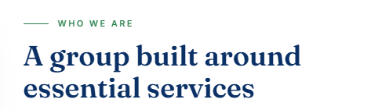
Change to ---- A group creating Value Through Businesses That Keep the World Moving
LS Global Holdings is a multinational group operating across the United States, Senegal, and The Gambia, with businesses in residential care, fire safety, transportation, and clean-energy infrastructure.
Each company operates independently under its own brand and serves its own customers, while benefiting from the strength of a unified group. LS Global Holdings provides shared leadership, governance, financial oversight, operational standards, and compliance across all three countries.
Together, our companies are united by a common purpose: to provide essential services that support people, communities, and sustainable growth.

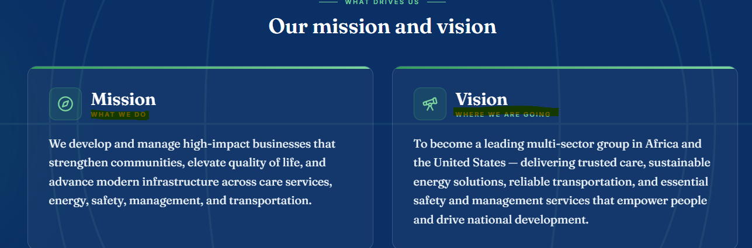
Remove the painted writing --- under Mission and Vision. --- What We do and where we are going.
VISION
To become a leading multi-sector group across Africa and the United States, delivering trusted care, sustainable energy, reliable transportation, and essential safety and management services that strengthen communities and support long-term economic development.
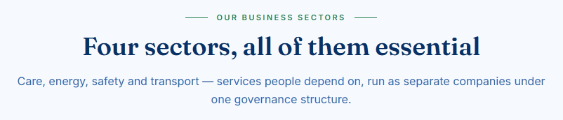
Essential Services. Shared Strength. --- this replaces –Four Sector ……… the Care , energy –replaces the writes here.

Other strong options are Built Around What Matters, Four Sectors. One Purpose., One Group. Four Essential Sectors., and Serving the Essentials of Everyday Life.

My preference for LS Global Holdings is “Essential Services. Shared Strength.” because it feels corporate, memorable, and fits the multi-sector structure well.

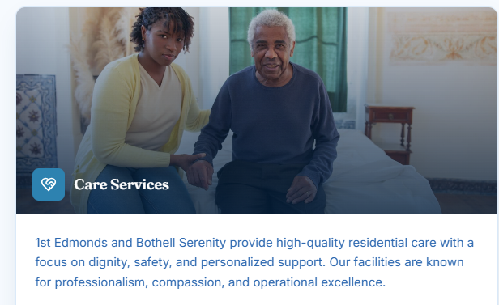
1st Edmonds and Bothell Serenity provide high-quality residential care focused on dignity, safety, and personalized support. Our homes combine compassionate care with professional standards in a safe and welcoming environment.

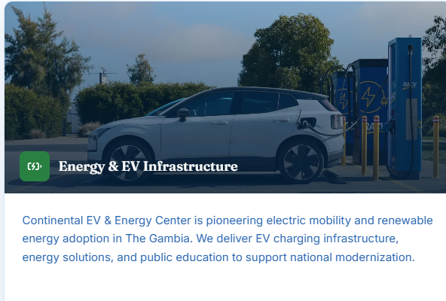
Continental EV & Energy Center is building the infrastructure for The Gambia’s transition to electric mobility and clean energy. Through EV charging networks, scalable energy solutions, and market development, the company is positioned to support the country’s growing demand for modern, sustainable infrastructure.

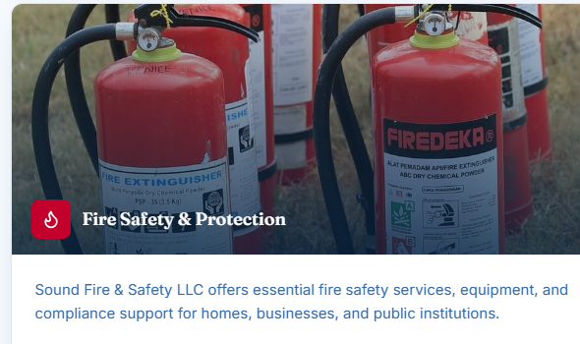
Sound Fire & Safety LLC provides essential fire protection, equipment, and compliance solutions across residential, commercial, and public sectors. Recurring inspections, maintenance, and refilling services foster long-term customer relationships and consistent service demand.

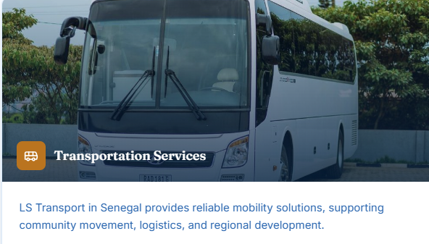
LS Transport provides reliable mobility solutions across Senegal, connecting people, businesses, and communities. Its services strengthen regional connectivity and support economic growth.

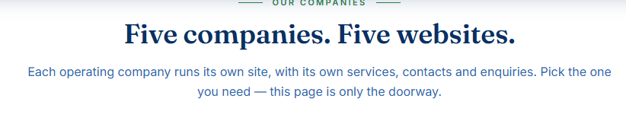
One Global Group. Essential Services.

Each LS Global Holdings company operates independently, with its own services, website, and customer contacts. Choose a company below to explore its services and connect directly with the team.

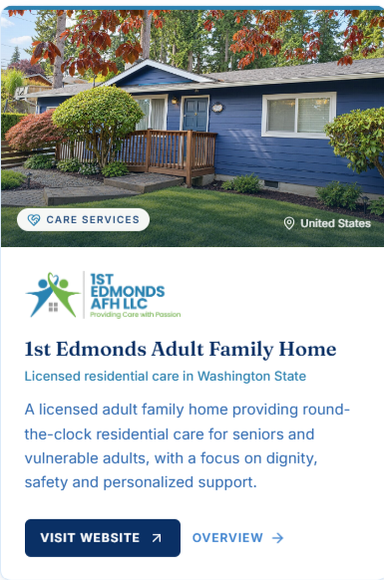
1st Edmonds Adult Family Home

Personalized Residential Care in Washington State

A licensed adult family home providing 24-hour care for seniors and vulnerable adults in a warm, home-like setting where dignity, comfort, safety, and personalized support come first.

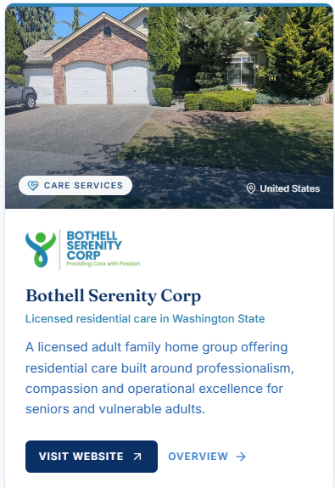
Bothell Serenity Corp

Personalized Residential Care in Washington State

A licensed adult family home group providing 24-hour care tailored to each resident’s individual needs, preferences, and routines—delivered with compassion, dignity, and professional support in a home-like setting.

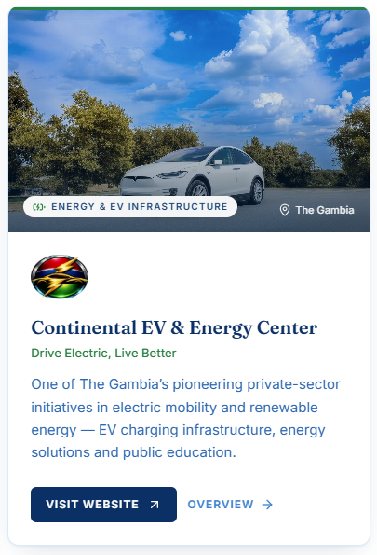
Continental EV & Energy Center

Drive Electric. Live Better.

Delivering practical clean-energy solutions for The Gambia through EV charging infrastructure, reliable energy systems, and public education—making electric mobility and sustainable energy more accessible for everyday use.

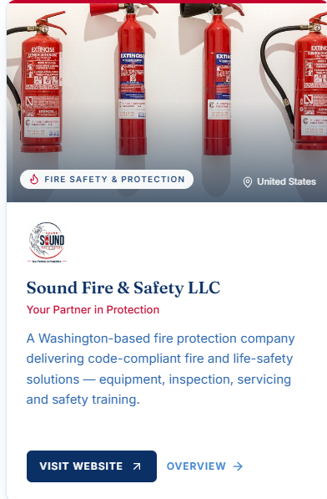
Sound Fire & Safety LLC

Your Partner in Protection

Providing reliable fire and life-safety solutions across Washington, with ongoing inspections, maintenance, refilling, and compliance support designed to keep customers protected, prepared, and supported year after year.

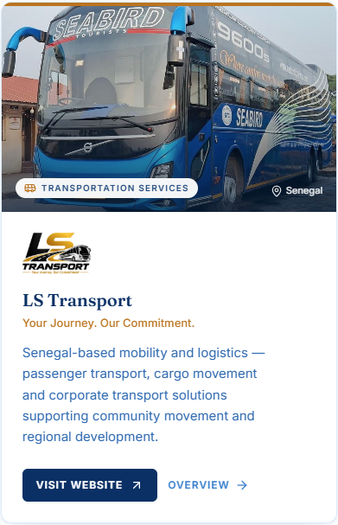
LS Transport

Your Journey. Our Commitment.

Providing reliable passenger, cargo, and corporate transport across Senegal—strengthening regional connectivity, expanding access to essential mobility, and supporting local economic development.

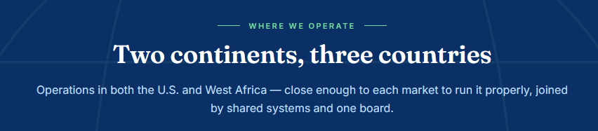
Global Reach. Local Presence.

With established operations in the United States, Senegal, and The Gambia, each LS Global Holdings company is locally managed and connected to the communities it serves, while benefiting from shared governance, systems, and strategic oversight across the group.

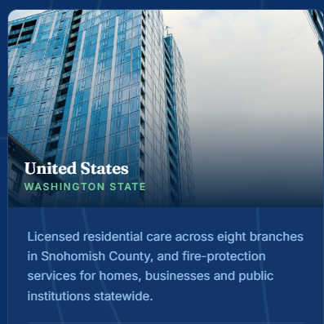
WASHINGTON STATE
USA
In Snohomish County, our residential care operations serve seniors and vulnerable adults across eight licensed locations. Statewide, our fire protection business provides safety equipment, inspections, maintenance, and compliance support for homes, businesses, and public institutions.

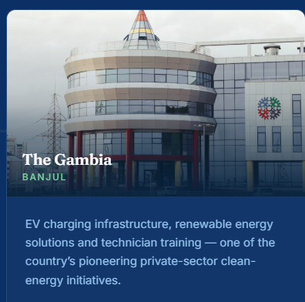

BANJUL
THE GAMBIA
One of The Gambia’s pioneering private-sector clean-energy initiatives, delivering EV charging infrastructure, practical renewable energy solutions, and technician training to support the country’s transition to sustainable energy.

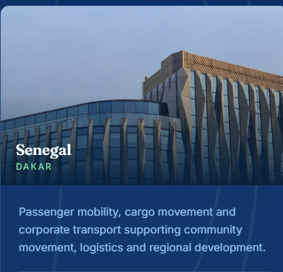
DAKAR
SENEGAL
Passenger transport, cargo and goods delivery, and dedicated corporate transport services—connecting communities, supporting business logistics, and strengthening regional development across Senegal.


Remove ----What every company in the group is held to.

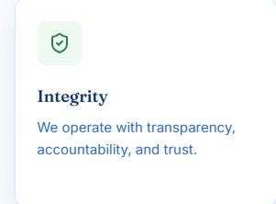
Integrity

We act with honesty, transparency, and accountability.

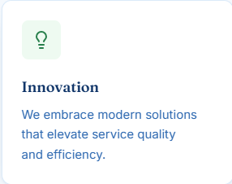
Innovation

We embrace modern solutions to deliver better, faster, and more reliable services for our customers.

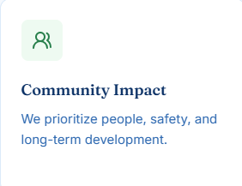
Community Impact

We strengthen communities through safer services, greater opportunity, and sustainable development.

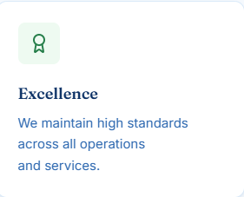
Excellence

We pursue excellence through exceptional standards, consistent quality, and dependable service.

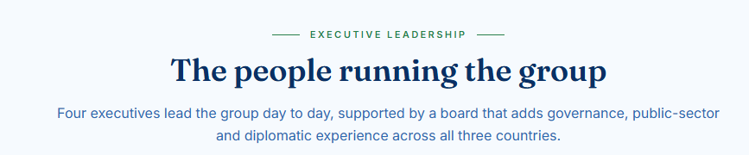
Leadership Across the Group

Our executive team manages strategy, operations, finance, and business growth across the group. The board provides governance, oversight, and public-sector and international expertise across the United States, Senegal, and The Gambia.

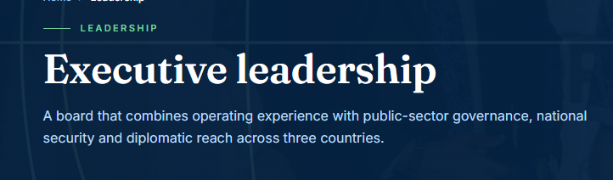

Proven Experience. Strategic Leadership.

Our board combines hands-on operating experience with expertise in public-sector governance, national security, law, finance, and diplomacy—providing practical insight and strategic oversight across the United States, Senegal, and The Gambia.

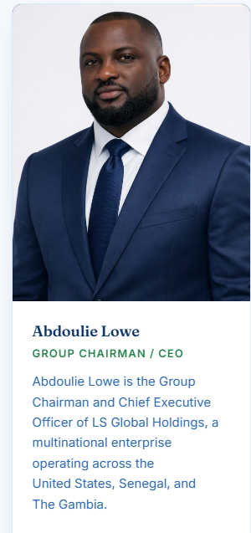
Abdoulie Lowe

GROUP CHAIRMAN & CHIEF EXECUTIVE OFFICER

Abdoulie Lowe leads LS Global Holdings across the United States, Senegal, and The Gambia, providing strategic direction, executive leadership, and oversight across the group’s diverse portfolio of companies.

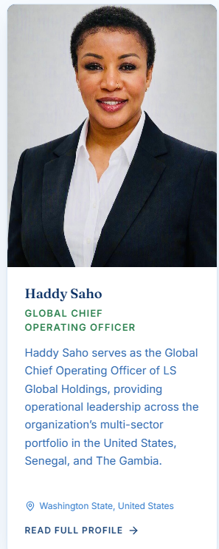
Haddy Saho

GLOBAL CHIEF OPERATING OFFICER

Haddy Saho leads operations across LS Global Holdings in the United States, Senegal, and The Gambia, providing operational leadership, organizational oversight, and coordination across the group’s diverse portfolio of companies.

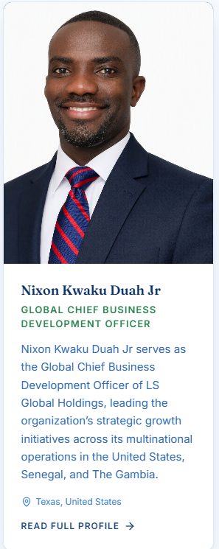
Nixon Kwaku Duah Jr

GLOBAL CHIEF BUSINESS DEVELOPMENT OFFICER

Nixon Kwaku Duah Jr leads business development across LS Global Holdings in the United States, Senegal, and The Gambia, driving strategic growth, partnerships, and new market opportunities across the group’s diverse portfolio of companies.

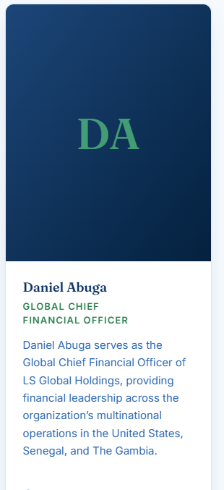
Daniel Abuga

GLOBAL CHIEF FINANCIAL OFFICER

Daniel Abuga leads financial management across LS Global Holdings in the United States, Senegal, and The Gambia, providing financial strategy, oversight, and fiscal discipline across the group’s diverse portfolio of companies.

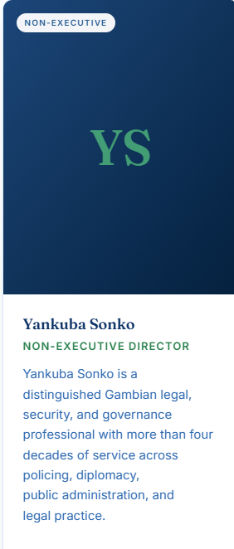

Yankuba Sonko

NON-EXECUTIVE DIRECTOR

Yankuba Sonko brings more than four decades of experience in legal practice, national security, policing, diplomacy, governance, and public administration, providing LS Global Holdings with strategic insight, legal perspective, and governance oversight.

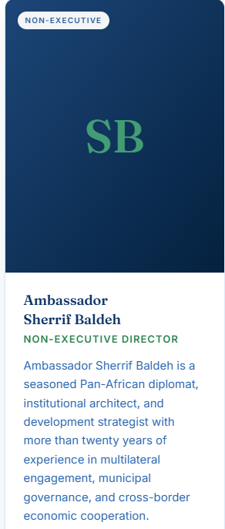
Ambassador Sherrif Baldeh

NON-EXECUTIVE DIRECTOR

Ambassador Sherrif Baldeh brings more than two decades of experience in diplomacy, institutional development, municipal governance, and cross-border economic cooperation, providing LS Global Holdings with strategic insight into international partnerships, regional development, and multilateral engagement.

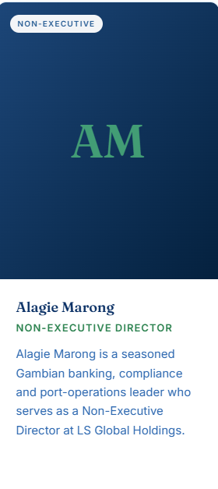
Alagie Marong

NON-EXECUTIVE DIRECTOR

Alagie Marong is a seasoned Gambian professional with extensive experience in banking, financial compliance, and port operations, bringing strong local market knowledge and valuable insight into financial governance, regulatory compliance, and operational oversight.

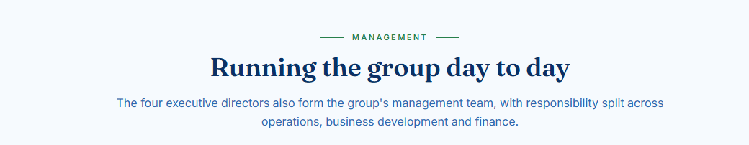

Leading the Group Day to Day

The four executive directors actively manage LS Global Holdings’ day-to-day operations, with direct responsibility for group strategy, operational performance, business development, and financial management.

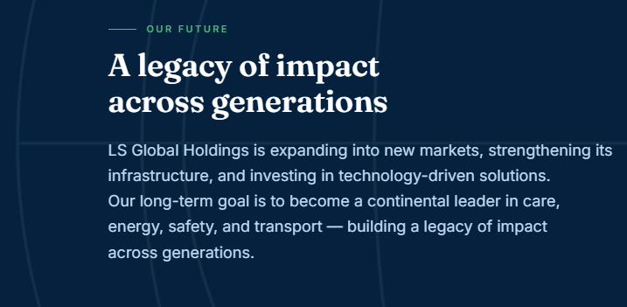
Building a Legacy Across Generations

LS Global Holdings is expanding into new markets, strengthening infrastructure, and investing in technology-driven solutions. Our long-term vision is to build a leading multi-sector group across Africa and the United States—creating lasting value for communities, economies, and future generations.

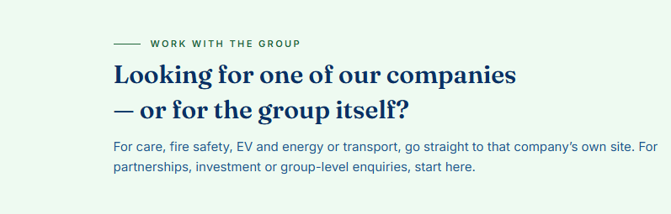
WORK WITH THE GROUP

Choose a company or connect with LS Global Holdings.

For care, fire safety, clean energy, or transportation, visit the relevant company’s website. For partnerships, investment opportunities, or group-level enquiries, contact LS Global Holdings directly.

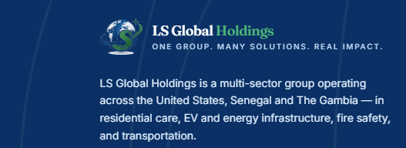
LS Global Holdings is a multi-sector group operating across the United States, Senegal, and The Gambia, delivering essential services in residential care, clean energy and EV infrastructure, fire safety, and transportation.

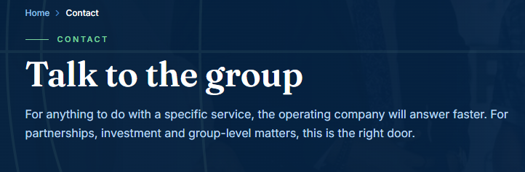
Executive Leadership in Action

The four executive directors lead LS Global Holdings’ day-to-day management, with direct responsibility for strategy, operations, business development, and financial oversight across the group.

